EXPERIMENT NO: 1
Title
Create a Simple Cloud Software Application and Provide it as a Service Using Zoho Creator to Demonstrate Software as a Service (SaaS)

Aim
To create a simple cloud software application using Zoho Creator and provide it as a service through the cloud to demonstrate the Software as a Service (SaaS) model.
Procedure
Step 1: Open a web browser and go to Zoho Creator.
Step 2: Sign in to your Zoho account using your login credentials.
Step 3: From the Zoho applications, select Zoho Creator.
Step 4: Click Create New Application and enter the application name, for example, Student Task Manager.
Step 5: Create the new application.
Step 6: Create a new Form and add fields such as Task Name, Description, Due Date, and Status.
Step 7: Save the form and enter sample task details.
Step 8: Create a report to display the submitted task records.
Step 9: Test the application through a web browser.
Step 10: Access the application through its cloud URL.
Application Used
Zoho Creator
Cloud Service Model
Software as a Service (SaaS)
Features of the Application
- Cloud-based application
- Accessible through a web browser
- No software installation required
- Stores data in the cloud
- Supports multiple users
- Easy to update and maintain
OUTPUT:

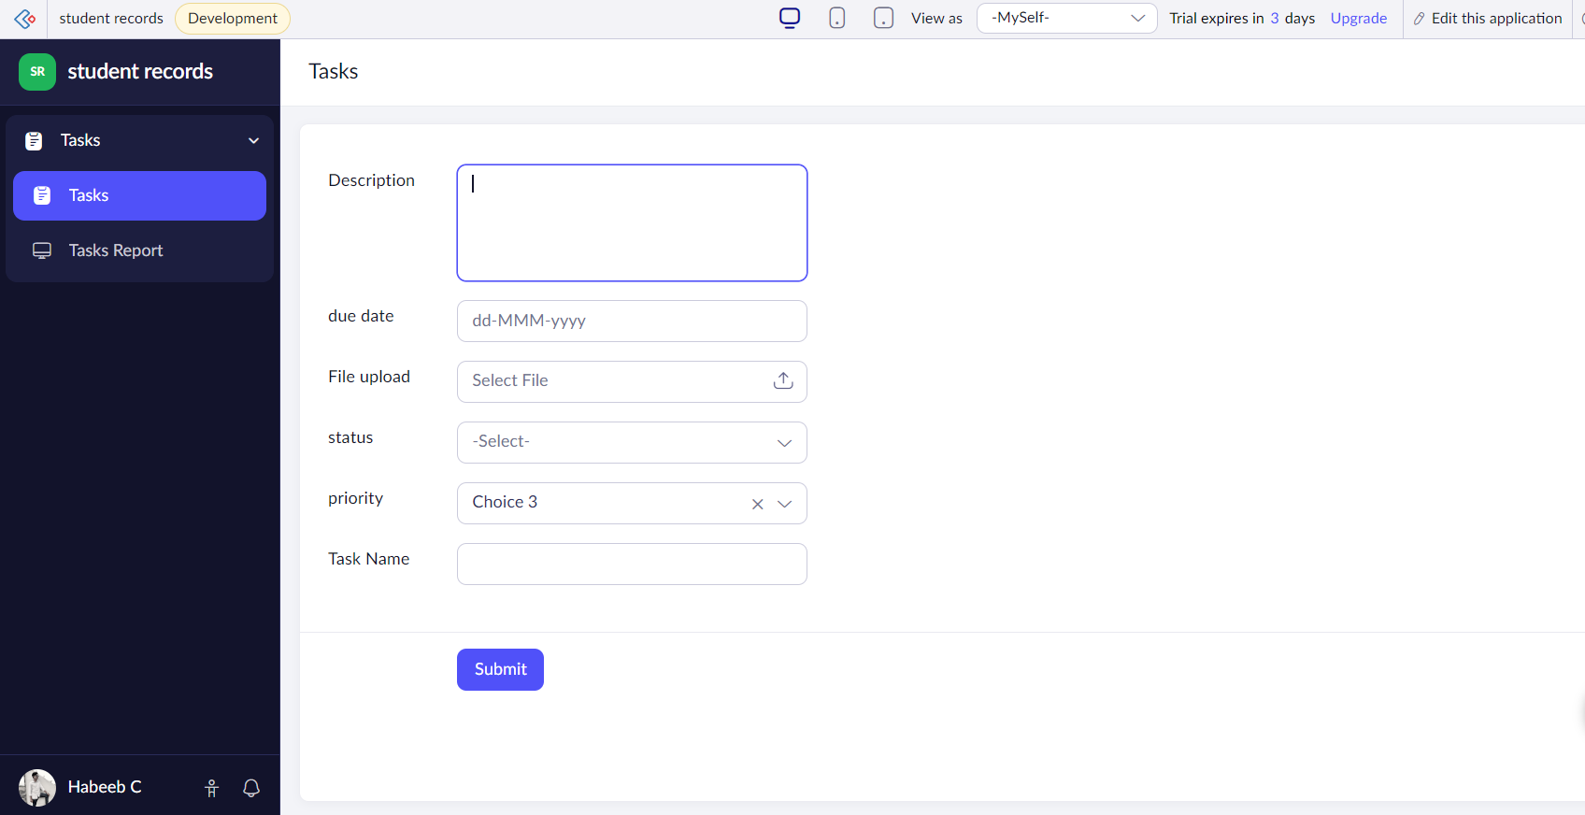

Result
A simple cloud software application was successfully created using Zoho Creator and provided as a Software as a Service (SaaS) application.

EXPERIMENT NO: 2
Title
Create a Simple Cloud Software Application for Flight Reservation System Using Zoho Creator to Demonstrate SaaS
Date: __________
Aim
To create a simple cloud-based Flight Reservation System using Zoho Creator and provide it as a Software as a Service (SaaS) application.
Procedure
Step 1: Open a web browser and go to Zoho Creator.
Step 2: Sign in to the Zoho account.
Step 3: Click Create New Application.
Step 4: Enter the application name as Flight Reservation System.
Step 5: Create a new Flight Reservation Form.
Step 6: Add fields such as Passenger Name, Email, Phone Number, Source, Destination, Travel Date, Number of Passengers, and Class.
Step 7: Save the form.
Step 8: Create a report to display the flight reservation details.
Step 9: Enter sample passenger and flight details.
Step 10: Test the reservation application through the web browser.
Step 11: Share/access the application through the generated cloud URL.
Application Used
Zoho Creator
Cloud Service Model
Software as a Service (SaaS)
Features of the Application
- Online flight reservation
- Passenger information management
- Source and destination selection
- Travel date management
- Passenger count
- Flight class selection
- Cloud-based data storage
- Browser-based access
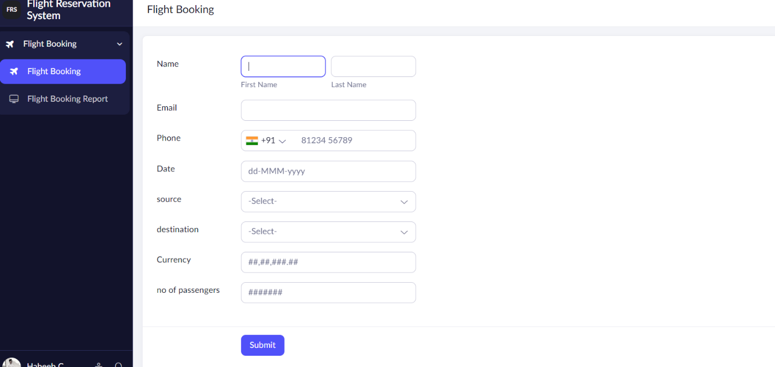

Result
A simple Flight Reservation System was successfully created using Zoho Creator and provided as a SaaS application.

EXPERIMENT NO: 3
Title
Create a Simple Cloud Software Application for Property Buying & Rental Process in Chennai City Using Zoho Creator to Demonstrate SaaS
Date: __________
Aim
To create a cloud-based Property Buying and Rental Application for Chennai City using Zoho Creator and demonstrate the Software as a Service (SaaS) model.
Procedure
Step 1: Open a web browser and go to Zoho Creator.
Step 2: Sign in to the Zoho account.
Step 3: Select Zoho Creator from the Zoho applications.
Step 4: Click Create New Application.
Step 5: Enter the application name as Chennai Property Management System.
Step 6: Create a new Property Form.
Step 7: Add fields such as Property Name, Property Type, Location, Area, Number of Bedrooms, Purpose, Price, Owner Name, and Contact Number.
Step 8: Add Chennai locations such as Tambaram, Anna Nagar, Porur, OMR, Adyar, and Velachery.
Step 9: Save the form and enter sample property details.
Step 10: Create a report to display available properties.
Step 11: Create filters for Buy and Rent properties.
Step 12: Test the application through a web browser.
Step 13: Access the application using the cloud URL.
Application Used
Zoho Creator
Cloud Service Model
Software as a Service (SaaS)
Features of the Application
- Chennai property listing
- Property buying option
- Property rental option
- Location-based property details
- Property type management
- Price information
- Owner contact details
- Cloud-based data storage
- Online access
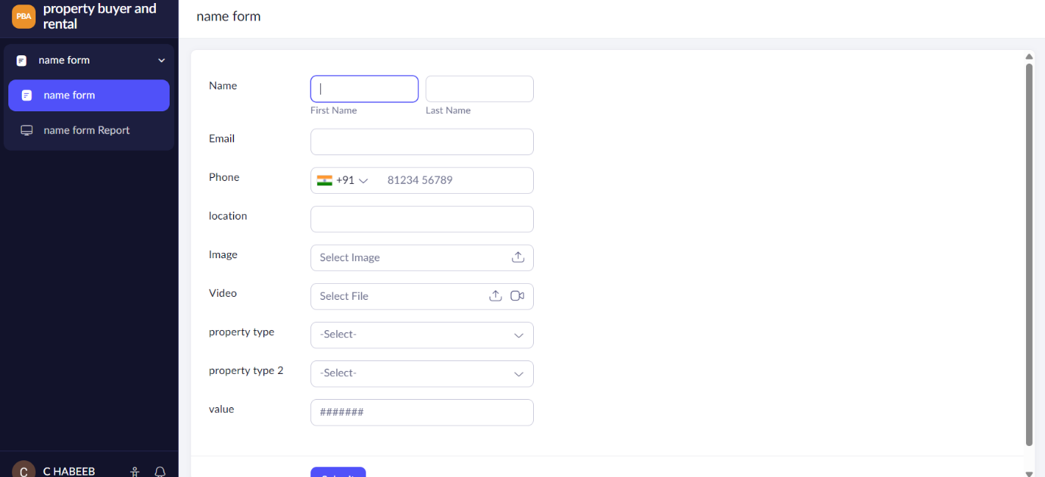

Result
A cloud-based Property Buying and Rental Application for Chennai City was successfully created using Zoho Creator and provided as a SaaS applicati
EXPERIMENT NO: 4
Title
Create a Simple Cloud Software Application for Car Booking Reservation System Using Zoho Creator to Demonstrate SaaS
Date: __________
Aim
To create a simple cloud-based Car Booking Reservation System using Zoho Creator and demonstrate the Software as a Service (SaaS) model.
Procedure
Step 1: Open a web browser and access Zoho Creator.
Step 2: Sign in to the Zoho account.
Step 3: Click Create New Application.
Step 4: Enter the application name as Car Booking Reservation System.
Step 5: Create a new Car Booking Form.
Step 6: Add fields such as Customer Name, Phone Number, Car Model, Car Type, Pickup Location, Drop Location, Booking Date, Return Date, and Number of Passengers.
Step 7: Add available car models and their rental details.
Step 8: Save the form.
Step 9: Create a report to display the booking details.
Step 10: Enter sample customer and booking information.
Step 11: Test the booking application.
Step 12: Access the application through the generated cloud URL.
Application Used
Zoho Creator
Cloud Service Model
Software as a Service (SaaS)
Features of the Application
- Online car booking
- Customer information management
- Car model selection
- Pickup and drop location
- Booking date management
- Return date management
- Passenger information
- Cloud-based booking records
- Browser-based access

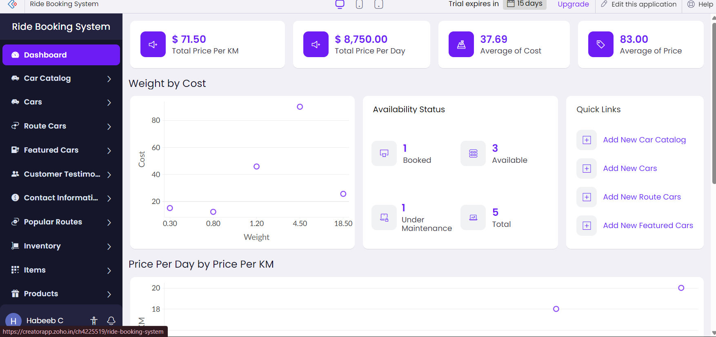
Result
A simple Car Booking Reservation System was successfully created using Zoho Creator and provided as a SaaS application.

EXPERIMENT NO: 5
Title
Create a Simple Cloud Software Application for Library Book Reservation System for SIMATS Library Using Zoho Creator to Demonstrate SaaS
Aim
To create a simple cloud-based Library Book Reservation System for SIMATS Library using Zoho Creator and demonstrate the Software as a Service (SaaS) model.
Procedure
Step 1: Open a web browser and access Zoho Creator.
Step 2: Sign in to the Zoho account.
Step 3: Click Create New Application.
Step 4: Enter the application name as SIMATS Library Book Reservation System.
Step 5: Create a new Book Reservation Form.
Step 6: Add fields such as Student Name, Register Number, Department, Book Title, Author, Book ID, Reservation Date, Return Date, and Status.
Step 7: Add available books to the application.
Step 8: Save the form.
Step 9: Create a report to display the book reservation records.
Step 10: Enter sample student and book details.
Step 11: Test the book reservation process.
Step 12: Access the application through the generated cloud URL.
Application Used
Zoho Creator
Cloud Service Model
Software as a Service (SaaS)
Features of the Application
- Online book reservation
- Student information management
- Book information management
- Book ID tracking
- Reservation date
- Return date
- Book availability status
- Cloud-based records
- Browser-based access
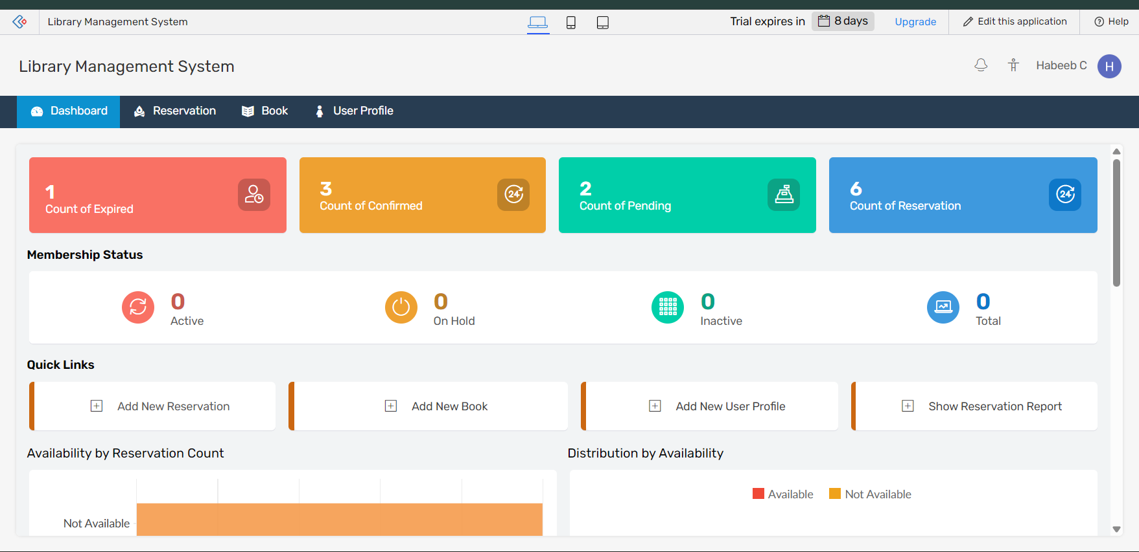

Result
A simple SIMATS Library Book Reservation System was successfully created using Zoho Creator and provided as a SaaS application.

EXPERIMENT NO: 6
Title
Create a Simple Cloud Software Application for Product Selling Using Zoho Creator to Demonstrate SaaS
Aim
To create a simple cloud-based Product Selling Application using Zoho Creator and demonstrate the Software as a Service (SaaS) model.
Procedure
Step 1: Open a web browser and access Zoho Creator.
Step 2: Sign in to the Zoho account.
Step 3: Click Create New Application.
Step 4: Enter the application name as Online Product Selling System.
Step 5: Create a new Product Form.
Step 6: Add fields such as Product Name, Product ID, Category, Description, Price, Quantity, Customer Name, Customer Email, and Contact Number.
Step 7: Add sample products to the application.
Step 8: Create an Order Form for customers.
Step 9: Add fields such as Customer Name, Product Name, Quantity, Order Date, and Payment Status.
Step 10: Create a report to display products and customer orders.
Step 11: Enter sample product and order details.
Step 12: Test the product selling application through a web browser.
Step 13: Access the application using the generated cloud URL.
Application Used
Zoho Creator
Cloud Service Model
Software as a Service (SaaS)
Features of the Application
- Online product listing
- Product category management
- Product price management
- Product quantity management
- Customer information
- Order management
- Payment status
- Cloud-based data storage
- Browser-based access
- Easy maintenance

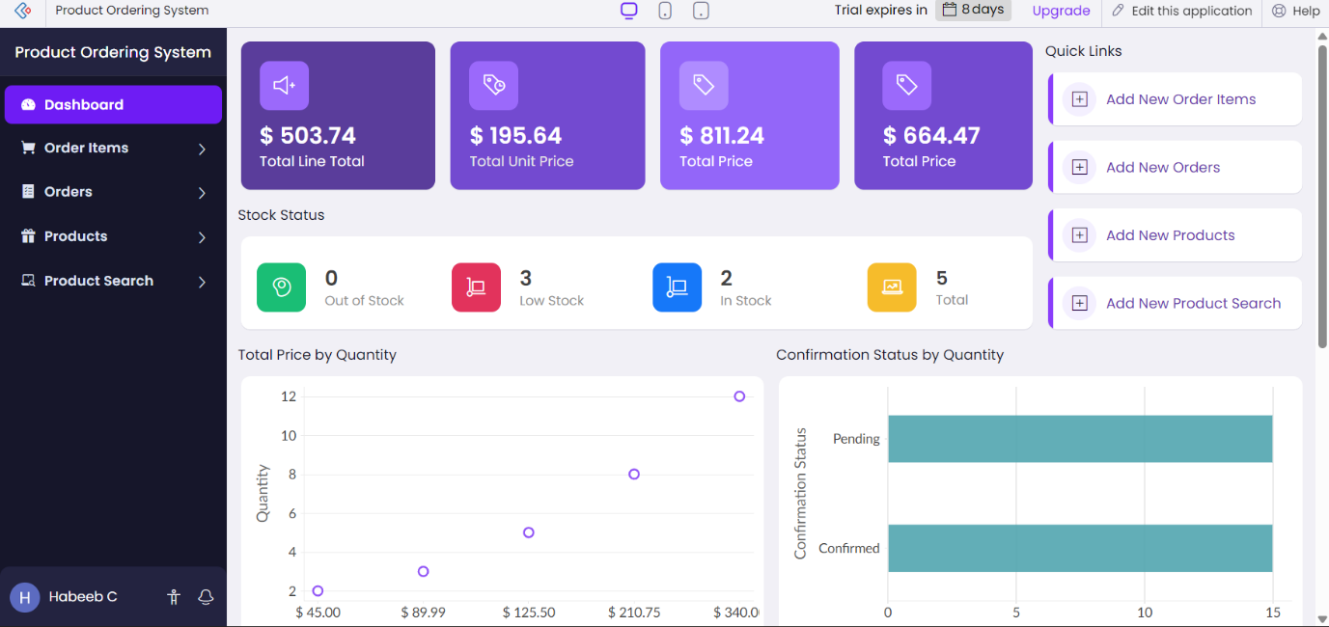

Result
A simple Product Selling Application was successfully created using Zoho Creator and provided as a Software as a Service (SaaS) application.

